**BAJAJ BIKE SALES ANALYSIS**

**PRECISION CUSTOMER PROFILING AND MARKET SEGMENTATION**

**1. Introduction:**

The core objective of this project is to conduct a detailed customer segmentation analysis to identify the true factors influencing a bike purchase. By isolating the specific demographic, socioeconomic, and lifestyle attributes that correlate most strongly with the 'Purchase Bike' outcome, the analysis aims to transition the sales and marketing strategy from generalized campaigns to Precision, high-ROI targeting.

Despite overall market success, Bajaj is currently incurring unnecessary campaign costs and leaving profit on the table by applying broad marketing strategies. The analysis addresses the core challenge of defining how the Sales and Marketing teams can develop a counter-intuitive messaging strategy that successfully engages high-value segments based on their intrinsic motivation (for instance utility, lifestyle) rather than pure disposable income.

**2. Key Datasets and Methodologies:**

The analysis utilizes the 2023 Bajaj Bike Sales dataset which combines Demographic, Socioeconomic, and Lifestyle customer attributes.

I extensively employed Microsoft Excel to**:**

* generate new categorical fields like 'Age Group' and 'Income Range'using IFS functions.
* create Pivot Tables used for cross-tabulation of independent variables (e.g., Region, Education) against the dependent variable (Purchase Bike) to volumetric share.
* utilize COUNTIFS and SUMIFS to verify the size and performance of specific multi-variable segments e.g., "Married men, Professional, Graduate, No Car".

**3. Story of Data:**

The derived data from Kaggle represents the aggregated customer profiles linked to successful and unsuccessful bike purchase events over the course of the year.

It is structured with rowsrepresenting individual customer records and columns representing the composite factors influencing the purchase decision. The analysis focuses on three key attribute categories:

* **Demographic Attributes:** Gender, Age, Marital Status, Education, Children.
* **Socioeconomic Factors:** Income, Home Owner, Occupation, Cars.
* **Lifestyle Factors:** Commute Distance, Region.

**Features and Their Significance:**

The Purchase Bike column (Dependent Variable) is the outcome being modeled and independent variables include: Education, Income, Commute Distance, and Region. The interaction of these variables is critical for defining the high-value customer persona, as the purchase decision is hypothesized to be driven by lifestyle utility rather than simple high income.

**Data Limitations:** The data does not capture changes in customer behavior over time.

4. **Data Splitting and Preprocessing:**

I ensured there are no blank rows, duplicate and consistency in categorical fields such as Occupation, Education, and Region using Excel's TRIM functions to ensure accurate grouping within Pivot Tables. There were basically no missing Values after inspection

Whilst transforming the data I appended a new column using nested IF statements to categorize raw Age into actionable groups ('Young', 'Middle Age', 'Old').

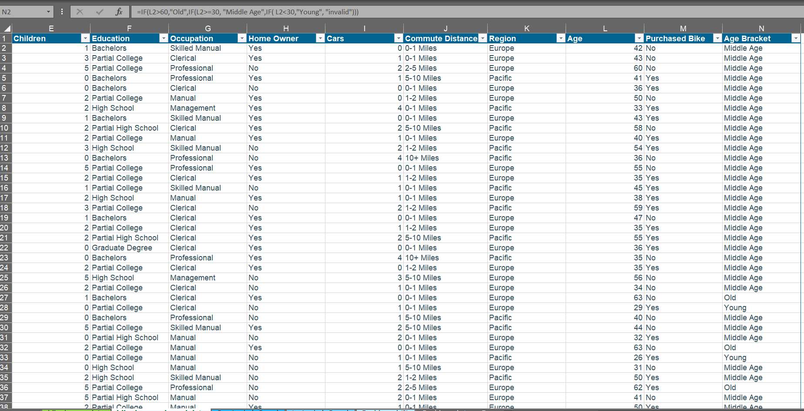

The raw Income column was also transformed into a categorical variable (e.g., '40,000−$69,999', '$70,000−$100,000') to align with marketing segmentation needs.

**5. Pre-Analysis**

**Data Categories:**

* Independent Variables: Education, Region, Occupation, Commute Distance
* Dependent Variables: Marital Status, Gender, Home Owner, Purchase Bike, Income, Age, Cars,

**Industry:** The industry is Transportation-Based Consumer Goods, specializing in two-wheeled vehicles (Bikes/Motorcycles). Success is defined by effectively reaching and engaging specific customer niches to drive profit and expand market reach.

**Stakeholders:** The key beneficiaries of this report are the Bike Store Owners, Marketing Team, and Sales Team.

**Value to the Industry:** This analysis provides the immediate value of optimizing marketing spend by precisely defining the most receptive audience. Understanding that a lower-income bracket is highly engaged, Bajaj can allocate resources away from campaigns targeting broad high-net-worth individuals and toward those focused on lifestyle benefits and utility for the mid-range earners.

I identified potential question that could be drawn from the data and the corresponding Potential Insight

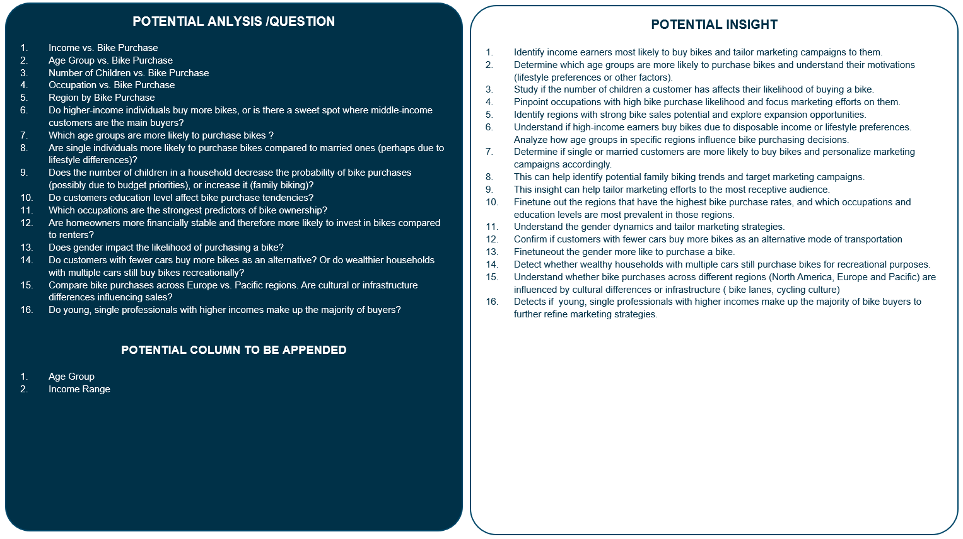

**6. In-Analysis**

The In-analysis phase was dedicated to using advanced Excel segmentation to validate the nuanced customer profiles across Regions, Occupation, Education Level, Income Earning, Age Group, Car Owned, and Commute Distance.

**Techniques Used:** Multi-Dimensional Pivot Tables and Calculated Fields within Pivot Tables was used to instantly calculate the share of sales by Region and Income Range for quick comparison and market size validation.

The analysis indicated an unexpected negative correlation in the Pacific region, where customers earning $40,000−$100,000 are *more* interested than the higher earning $130,000−$160,000 segment, suggesting lifestyle and utility are stronger predictors than disposable income alone

The data also suggests that the sales strategy is highly effective in **urban or suburban areas** where bikes are used for short, local trips, given that customers with a **0–1-mile commute distance** are top performers.

Furthermore, the number of cars owned does not prevent purchases, as customers with **one or two cars** remain strong buyers.

**7. Post-Analysis and Insights**

**Key Findings:**

1. **Core Buyer Definition:** The most likely buyers are people with a **Bachelor's or Partial College education** and a $40,000−$69,999 income.
2. **Geographical & Commute Hotspots:** North America and customers with a **0–1-mile commute distance** are top performers, emphasizing the effectiveness of the strategy in urban/suburban areas.
3. **North American Ideal:** The ideal North American customer is defined as a **married male professional** with a graduate degree, earning $70,000−$100,000, and without a car.
4. **Pacific Profile:** The most interested buyers in the Pacific region are **middle-aged males** with Bachelor's degrees, earning $70,000−$100,000, and owning one car.
5. **Income Refutation:** The analysis refutes the idea that the highest earners ($130,000−$160,000) are the most active buyers; instead, the $40,000−$100,000 groups are stronger, confirming that **lifestyle preference** drives the purchase.
6. **Management Worker Challenge:** Management workers, who are typically high-income earners with multiple cars, show different purchasing behaviors, suggesting their motivation is not aligned with the current product or campaign messaging.

**Comparison with Initial Findings:**

The analysis strongly **refuted the initial assumption from the In-Analysis** that high disposable income would be the most dominant predictor of bike purchase. Instead, the final findings shows that utility and lifestyle are the true drivers, not just wealth. The 45.74% dominance of North America was confirmed as the primary market imperative.

**8. Data Visualizations & Charts**

Below is high-level yet drillable interactive dashboard, accessible to all stakeholders,

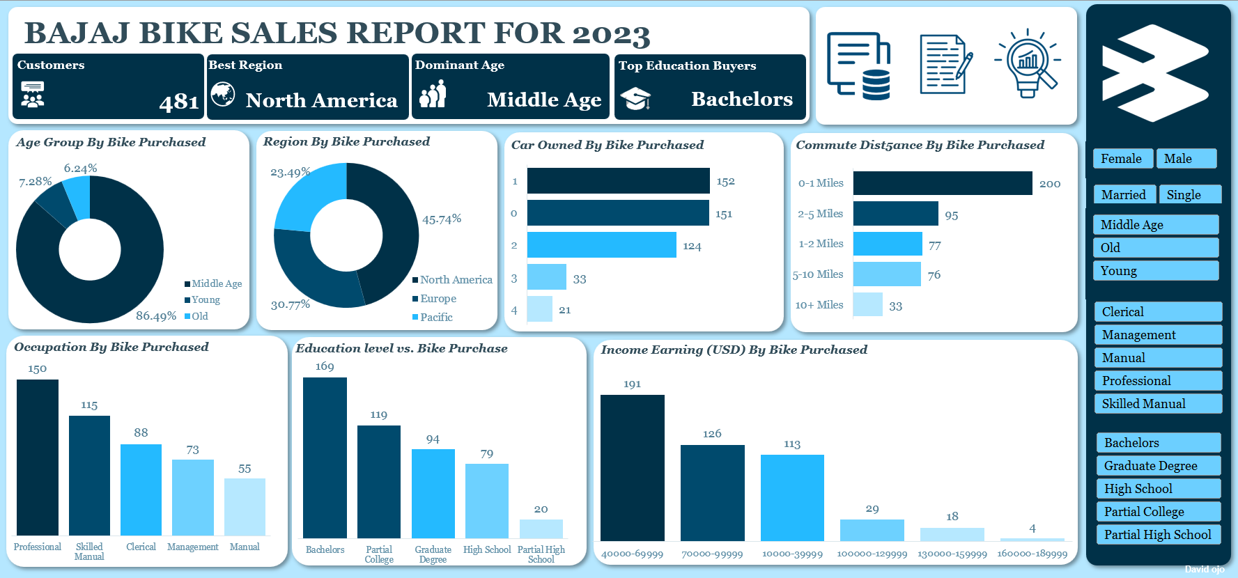

**Slicers:** Gender, Marital Status, Age Group, Education Level, Occupation

**Key Metrics Displayed:**

Total Customers: 481

Best Purchasing Region: North America

Dominant Age Group: Middle Age

Top Education Buyers: Bachelors degree holder

**Charts and Graphs Used:**

* **Pie Chart:**

**Age Group by Bike Purchased:** Illustrating North America's 45.74% dominance versus Pacific and Europe to guide budget allocation.

**Age Group by Bike Purchased**: Illustrating that the Middle Age group accounts for 86% of the bike purchase

* **Bar Chart:**

**Purchase Count by Commute Distance:** Demonstrating the drop-off in sales beyond the **0–1-mile** category to validate the utility focus.

**Car Owned by Bike Purchased:** Illustrating that customer with a one or no car are the most frequent buyers

* **Column Chart:**

**Occupation vs. Bike Purchase:** Comparing purchase rates across 'Professional', 'Management', and other categories, segmented by gender or marital status to identify the highest-performing group.

**Education level vs. Bike Purchase** Customers with a Bachelor's Degree are the most frequent buyers, showing more than double the sales volume of those with only a high school education.

**Income Earned by Bike Purchased:** Deduct that the $40,000−$69,999 income bracket is the largest customer base, confirming that upper-middle-class earners are the primary market drivers.

**9. Recommendations and Observations**

**Observation:**

* People with a Bachelor's and Partial college education, and those in the $40,000-$69,999 income bracket are the most likely buyers of bikes.
* The North American region and customers with a very short commute distance of 0-1 miles are the top performers showing that the sales strategy is most effective in urban or suburban areas where bikes are used for short, local trips.
* Having a car doesn't stop people from buying a bike. Customers with one or no cars are the top buyers, but those with two cars are a strong third.
* In the pacific region, the middle age group customer base, Bachelor’s degree holders with one car, earning between $70,000 to $100,000, and predominantly male, are the most interested in purchasing bikes.
* Further analysis shows that this behavior is due to lifestyle preference rather than high disposable income as the least performing customer base within this group earns between $130,000 to $160,000, while the highest performing group earns between $40,000 to $100,000.
* Professional workers in North America with graduate degrees or partial college education, earning between $70,000 to $100,000, and without cars, are the most willing to buy bikes (Married men to be precise).
* The highest purchasers of bikes in North America among the Middle age group are those who commute between 0-1 mile, own at least one car, and are professional workers earning between $40,000 to $100,000.
* Customers with a Bachelor's degree are our most frequent buyers, with more than double the sales of those with only a high school education and this trend is mirrored in income, as the $40,000-$69,999 income bracket is our largest customer base.
* North America is our primary market, accounting for nearly half of all sales (45.74%).
* Our ideal customer in North America is likely a married male professional with a graduate degree, earning between $70,000-$100,000, and who does not own a car.
* In the Pacific region, the most interested buyers are middle-aged males, with Bachelor's degrees, earning $70,000-$100,000, and owning one car. This behavior appears to be driven by lifestyle preferences rather than income, given that higher-earning customers in this region show less interest.
* While professionals are our top buyers, management workers show different behaviors. They are typically high-income earners with multiple cars (1-3), suggesting their purchasing decisions are likely influenced by a preference for convenience and lifestyle, which may not align with our current product offerings.

**Specific Recommendations:**

* **Targeted Promotion Focus:** Shift promotions to customers with a Bachelor's/Partial College education and those earning $40,000−$69,999, as they are the most frequent, high-volume buyers.
* **North American Campaign Refinement:** Build focused campaigns around the ideal North American persona (married male professional, graduate degree, $70,000−$100,000, no car), emphasizing the bike as practical, professional-friendly transport.
* **Pacific Lifestyle Messaging:** In the Pacific region, target middle-aged men with one car, emphasizing lifestyle benefits, wellness, and self-care over affordability, given their higher income and purchase driver.
* **Complementary Messaging:** Design campaigns that explicitly show bikes as **complementary to cars**, encouraging multi-car households (especially those with two cars) to view biking as an enjoyable, short-distance alternative, rather than just a cost-saving measure.
* **Urban/Suburban Focus:** Increase marketing presence in North American urban and suburban areas, leveraging the strong 0−1 mile commute data point.

**Unexpected Outcomes:** The most unexpected outcome is the behavior of **Management workers as t**heir profile (high-income, multiple cars) does not align with the current buyer trend, suggesting the existing product and messaging is irrelevant to their motivations (likely prestige, convenience, or wellness). Thus, a **separate, prestige-focused strategy** is required for this lucrative but unengaged segment.

**10. Conclusion**

This project successfully demonstrates that the purchasing decision for Bajaj Bikes is not simply a function of wealth, but a sophisticated intersection of specific demographic, educational, and lifestyle factors. The analysis, powered by detailed segmentation in Excel, has moved the company's understanding from 'high income is key' to 'lifestyle utility for the $40k−$100k earner is the driver.' North America is confirmed as the priority market, but precision in defining the ideal buyer is the necessary key to maximum profit.

**Limitation:**

However. the primary limitation is the lack of **time-series data**, which prevents an analysis of how customer profiles or regional market shares have changed year-over-year. Additionally, the analysis is limited to the provided attributes and does not account for external factors like competitor pricing or seasonal marketing efforts.

**Future Research:**

1. Conduct a specific analysis to profile and understand the motivations of the Management worker segment to develop product or messaging concepts (prestige, high-end accessories) that appeal to their unique purchasing drivers.
2. Design and execute marketing campaigns tailored specifically to the $40,000−$69,999 and $70,000−$100,000 segments to quantify the true ROI impact of precision targeting.

**11. References**

* Bike Sales Dataset (Kaggle)
* Microsoft Excel (Analytical Tool)